TCP Scapy Development and Wireshark Analysis

Table of Contents
1. Learning Outcomes 3
2. Background Notes for Instructor 3
3. TCP Request/Response (Success on First Attempt) 3
4. Normal TCP Traffic – Failure and Correction 4
5. Error Traffic 5
6. Wireshark Analyst Section 7
Step-by-Step Instructions 7
showing request/response. 8
showing normal SYN 10
showing abnormal/error packet 11
Possible Improvements for Scapy Packets 13
7. Guided Questions (Worksheet Style) 13
Short Check Questions 13
Extended Lab Worksheet Questions 13
8. Takeaways 14

1. Learning Outcomes
By the end of this lab, students should be able to:
- Understand how TCP request/response traffic is generated with Scapy.
- Recognize differences between working packet scripts and failed attempts.
- Use Wireshark to analyze Scapy-generated traffic.
- Identify key TCP fields such as sequence numbers, flags, and ports.
- Critically assess how traffic can be improved for clarity.

2. Background Notes for Instructor
- We experimented with Scapy to generate TCP request/response, normal traffic, and error traffic.
- Not all attempts were successful: failed code versions are shown alongside corrected ones.
- AI-assisted development was used in refining the code to produce functional traffic.
- Captures from both Scapy and Wireshark should be inserted at the marked locations.

3. TCP Request/Response (Success on First Attempt)
- We generated TCP request/response traffic correctly on the first attempt.
- No major debugging was required.
- AI-aided code generation streamlined the process.
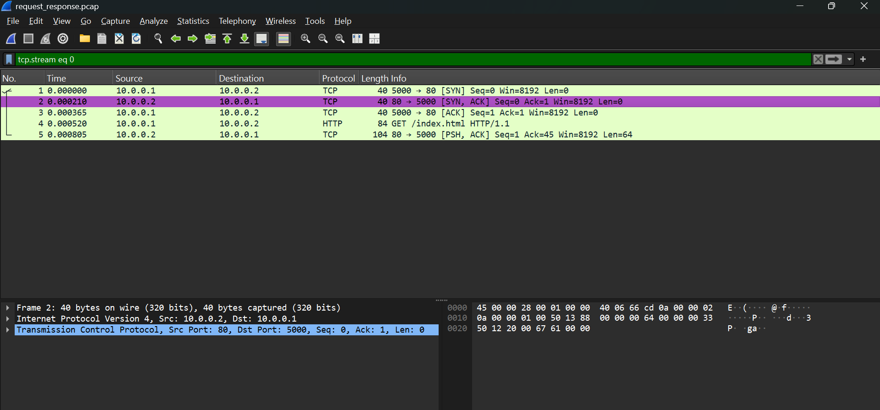

4. Normal TCP Traffic – Failure and Correction
First attempts at generating packets failed due to malformed flags and missing fields.
After corrections, we successfully generated TCP, HTTP, DNS, and ICMP traffic.
This shows the value of iteration and debugging when simulating realistic traffic.
AI-assisted code generation accelerated fixing the mistakes.

Failed Attempt
from scapy.all import *

# Initial incorrect code
pkt = IP(dst="192.168.1.1")/TCP(dport=80, flags="SYN")
send(pkt)
- Problem: flags="SYN" is invalid (should be "S") → script fails.

Corrected Attempt
from scapy.all import *

# Corrected normal TCP traffic
pkt = IP(dst="192.168.1.1")/TCP(dport=80, flags="S")
send(pkt)
- Correction: "S" is the valid flag.
- Packet sends successfully, appears in Wireshark.
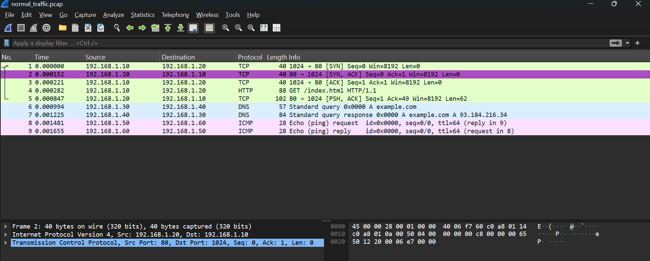
Teaching Notes:
- Highlight the 3-way handshake between 192.168.1.10 and 192.168.1.20.
- Point out the HTTP GET request (Frame 4).
- Show the DNS request and response (Frames 6 & 7).
- Explain the ICMP Echo Request/Reply (Frames 8 & 9).

5. Error Traffic
Error traffic was deliberately generated using malformed or incomplete packets.
Wireshark’s Expert Information Tool flagged these issues.
Examples of Errors
- TCP SYN sent but no SYN/ACK response.
- DNS query issued but no response.
- ICMP Echo Request sent but no reply.
These errors demonstrate the importance of valid packet construction.
AI-guided debugging helped us fix these issues in later iterations.

from scapy.all import *

# Simulating abnormal/error-like traffic
pkt = IP(dst="192.168.1.1")/TCP(dport=80, flags="FPU")
send(pkt)
- "FPU" is unusual (FIN + PUSH + URG) → looks suspicious in Wireshark.
- Demonstrates how “error-like” traffic may be crafted.
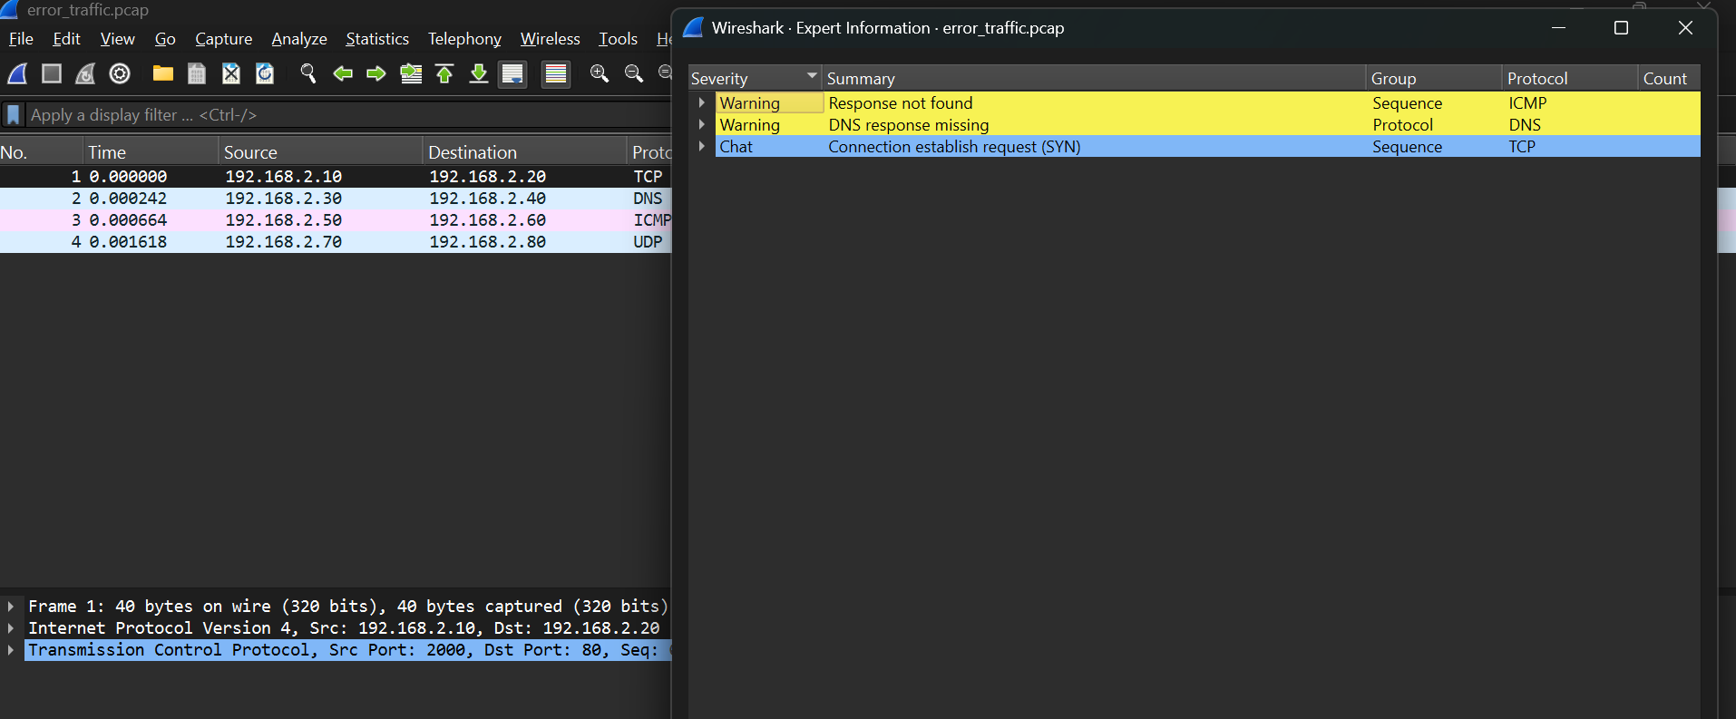
Teaching Notes:
- Highlight how Wireshark detects incomplete communications.
- Explain why a SYN without SYN/ACK means the TCP handshake failed.
- Show that a DNS query without response can be caused by missing server-side packets.
- Compare against the successful normal_traffic.pcap capture.

6. Wireshark Analyst Section

Step-by-Step Instructions
- Open .pcap file in Wireshark (File → Open).
- Apply basic TCP filter:
- tcp
- Inspect packet details (expand IP + TCP headers).
- Note sequence number, acknowledgment number, and flags.
- Compare normal vs. error traffic captures.

showing request/response.
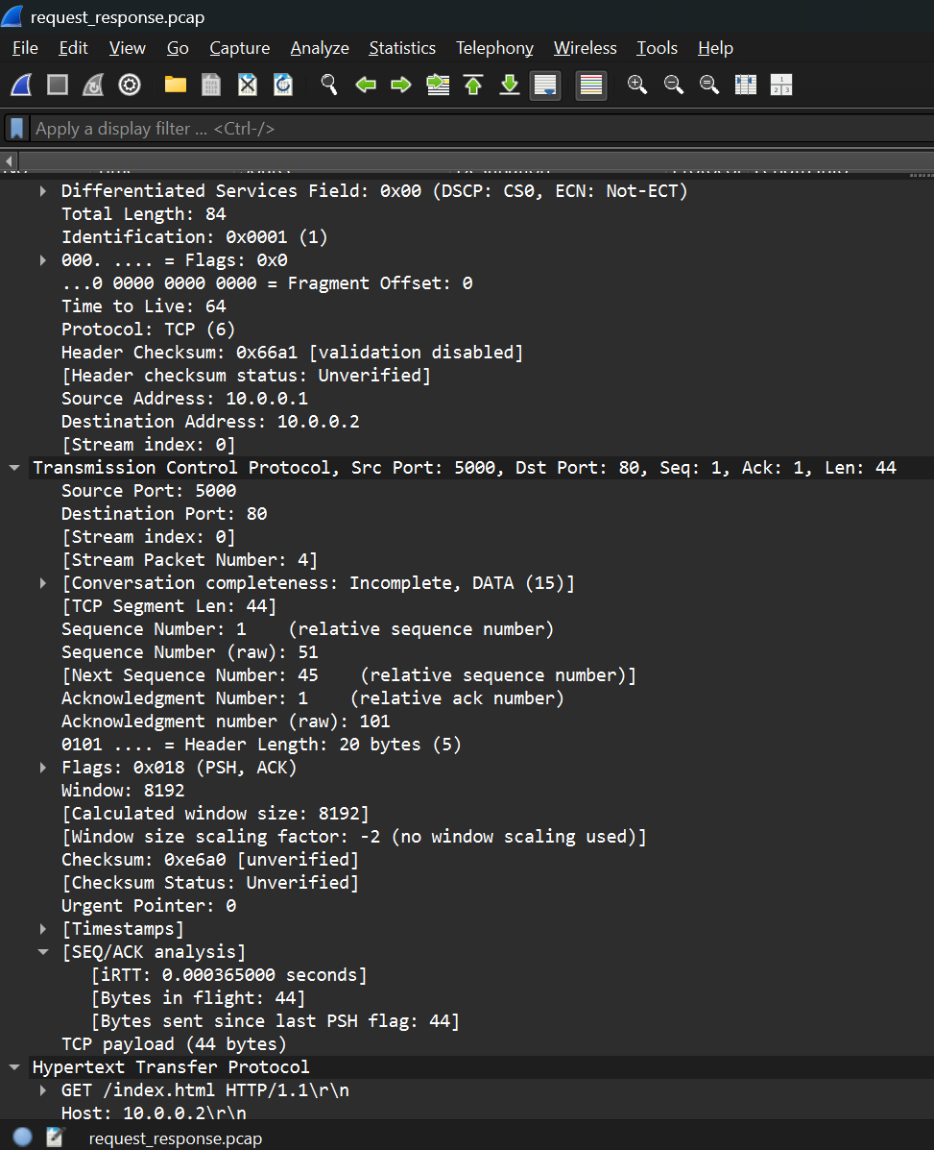
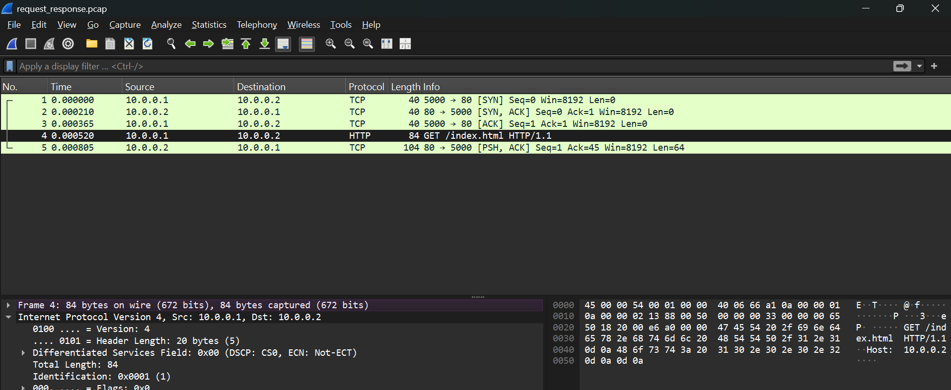

showing normal SYN
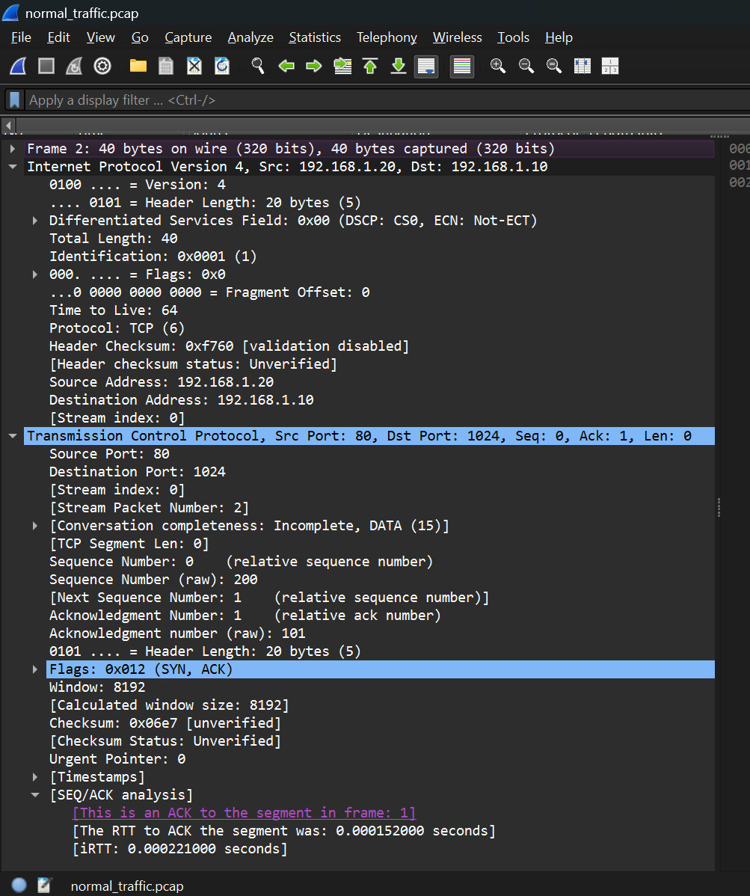
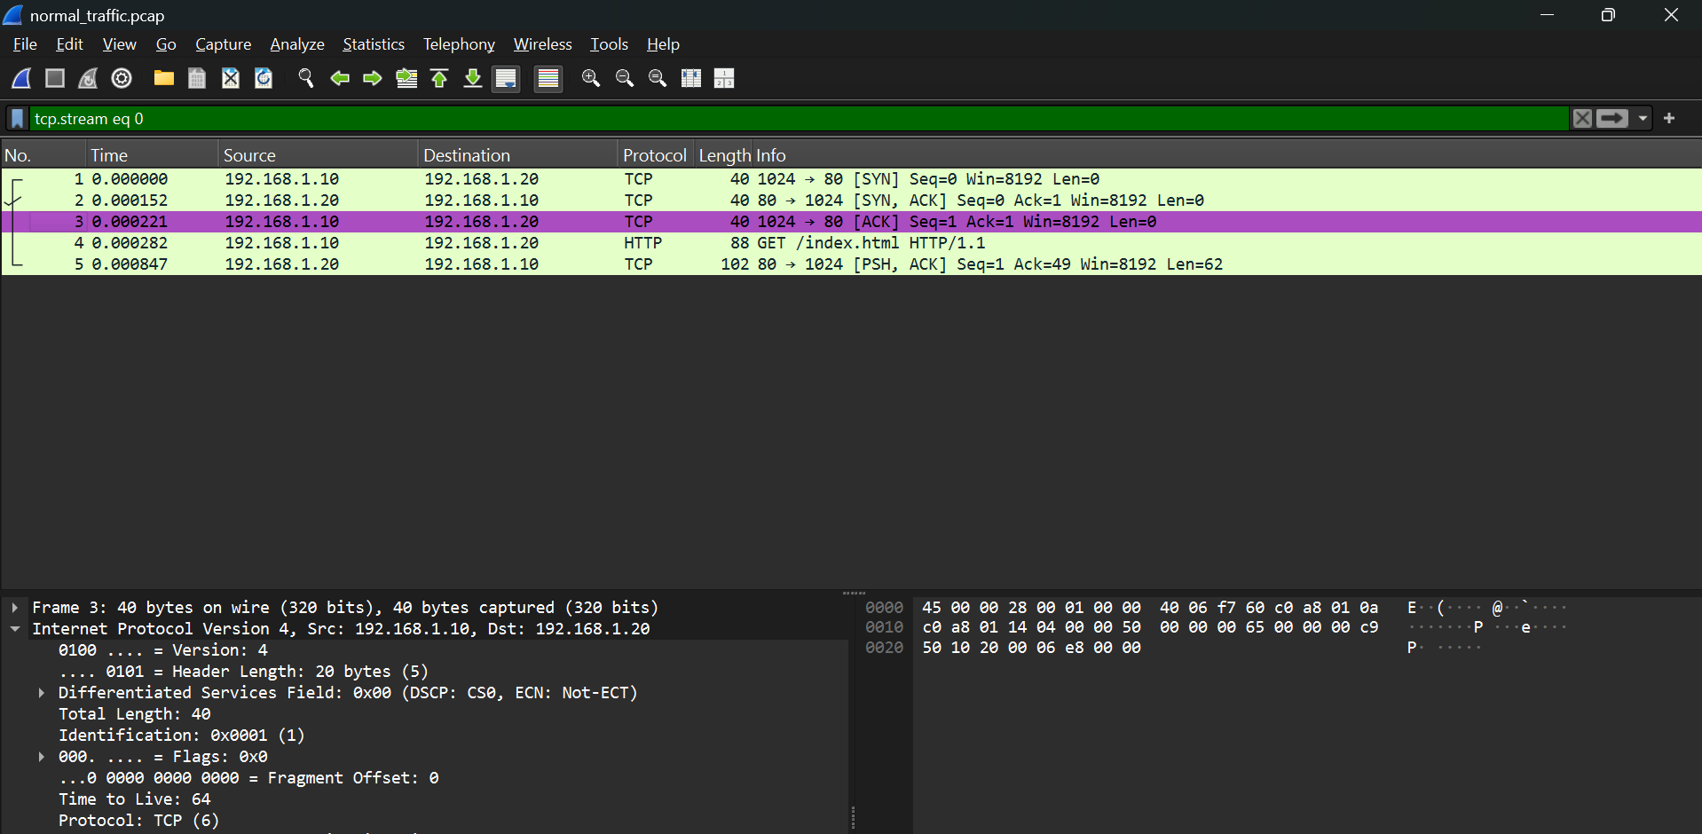

showing abnormal/error packet
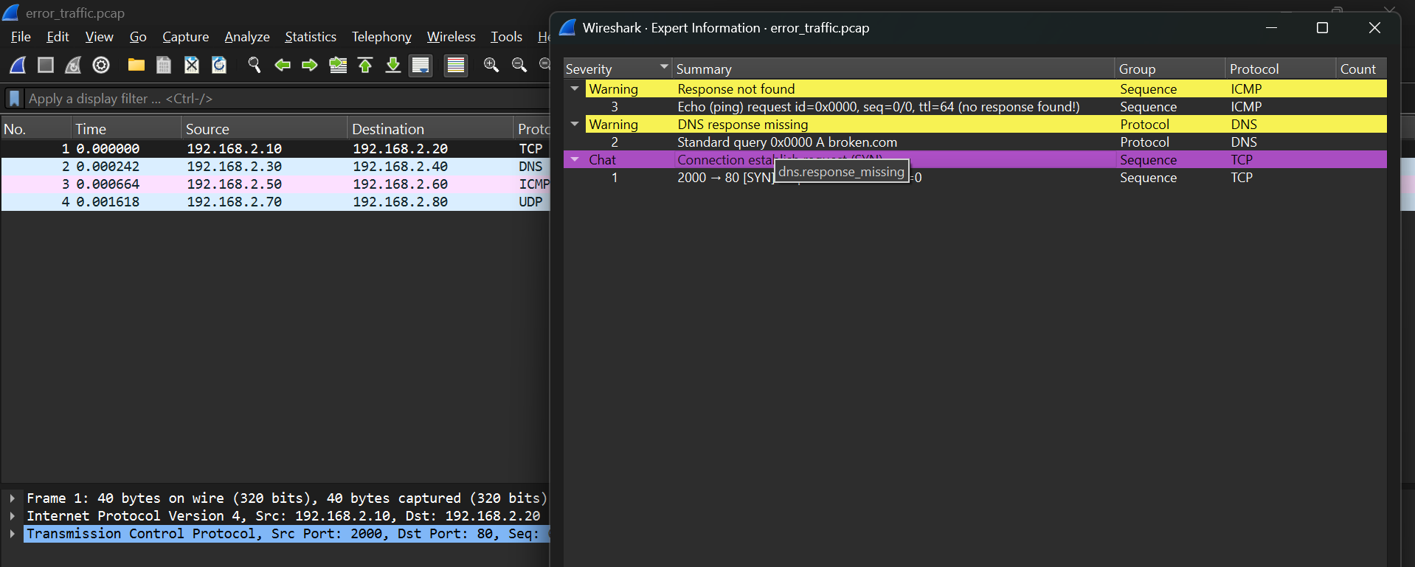
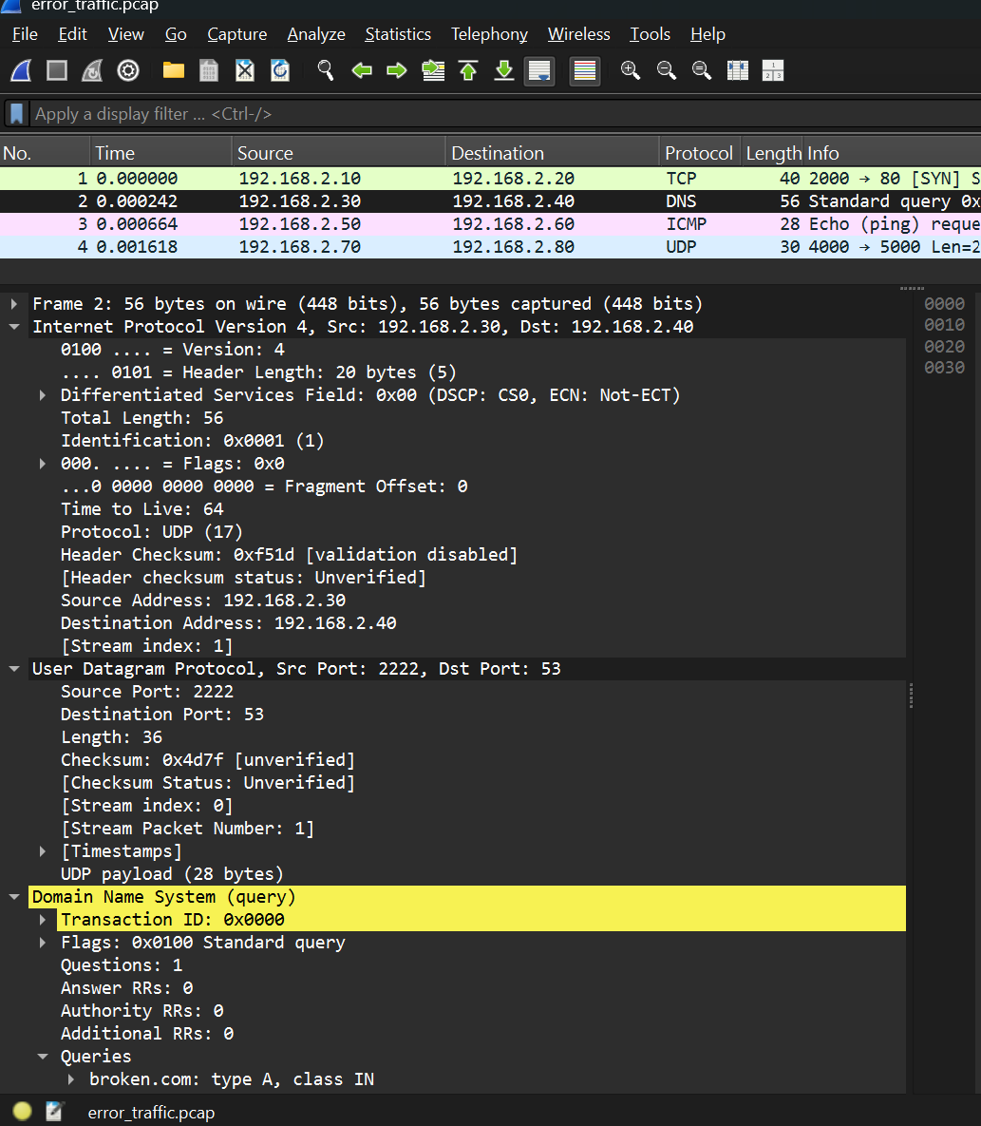

Initial Analysis Notes
- Request/response traffic: fields look correct.
- Normal traffic: SYN packet displays expected handshake initiation.
- Error traffic: unusual flags stand out (likely ignored/dropped by host).

Possible Improvements for Scapy Packets
- Add payload data for realism.
- Use proper source/destination ports to simulate client-server interaction.
- Generate a full handshake (SYN → SYN-ACK → ACK).
- Label packets clearly for students before exporting .pcap.

7. Guided Questions (Worksheet Style)

Short Check Questions
Q1: What flag is set in a SYN packet?
➡️ (S)
Q2: Which TCP fields are critical for tracking connection state?
➡️ (Sequence number, acknowledgment number, flags, ports)
Q3: What happens if invalid flags are used in Scapy?
➡️ (Packet may fail to send or be dropped as abnormal traffic)

Extended Lab Worksheet Questions
- Open the Scapy .pcap file in Wireshark. What filter do you apply to see only TCP traffic?
➡️ (tcp)
- Identify the source and destination IP addresses in the first packet.
➡️ (Answers vary)
- What is the sequence number of the SYN packet?
➡️ (Answers vary depending on capture)
- Compare the flags in the normal SYN packet vs. the abnormal error packet. What differences do you see?
➡️ (S vs. FPU)
- Why might a server ignore a packet with unusual flag combinations?
➡️ (It doesn’t conform to TCP handshake rules)
- In the request/response example, identify the ACK number. What does it confirm?
➡️ (It confirms receipt of the previous sequence number + 1)
- What improvements could be made to the Scapy packets to simulate more realistic traffic?
➡️ (Add payloads, full handshakes, proper ports)
- Reflect: How did AI assistance contribute to building the Scapy code examples?
➡️ (Faster debugging, correction of flag errors, more reliable scripts)

8. Takeaways
- TCP traffic can be crafted in Scapy, but mistakes in flag use or syntax lead to failed attempts.
- Request/response worked immediately, showing how Scapy can handle simple flows easily.
- Error traffic illustrates how anomalies appear in Wireshark.
- Wireshark analysis validates Scapy output and trains observation skills.
- AI support in development accelerated debugging and ensured working packet examples.

